Steps to Set-up Eshop-main - E-commerce Website using Django

Step :1 Download python version 10 and install
https://www.python.org/downloads/release/python-3100/
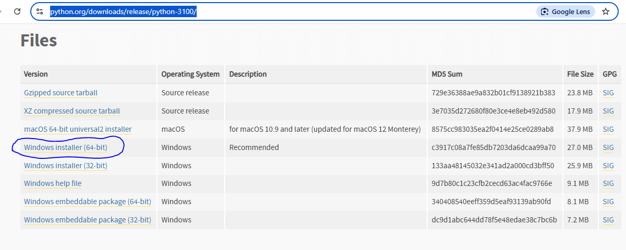
✅ During installation:
- Check ✅ "Add Python to PATH"
- Select ✅ "Install for all users" (if available)
Step :2 Download PyCharm Community Edition and install
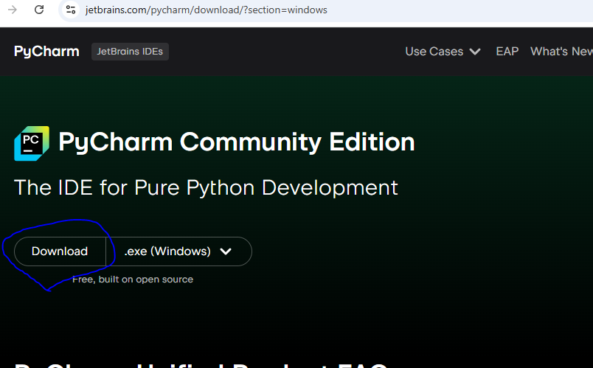

Step :3 Copy “Eshop-main” folder in default python path (eg. C:\Users\user\PycharmProjects\PythonProject)

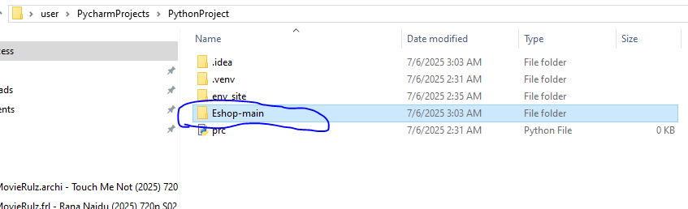

Step :4 Open terminal in PyCharm and run below commands
Commands are as blow:
python -m pip install -U pip
python -m venv env_site
.\env_site\Scripts\activate.ps1
pip install django
cd .\Eshop-main\
pip install -r requirements.txt
python manage.py runserver
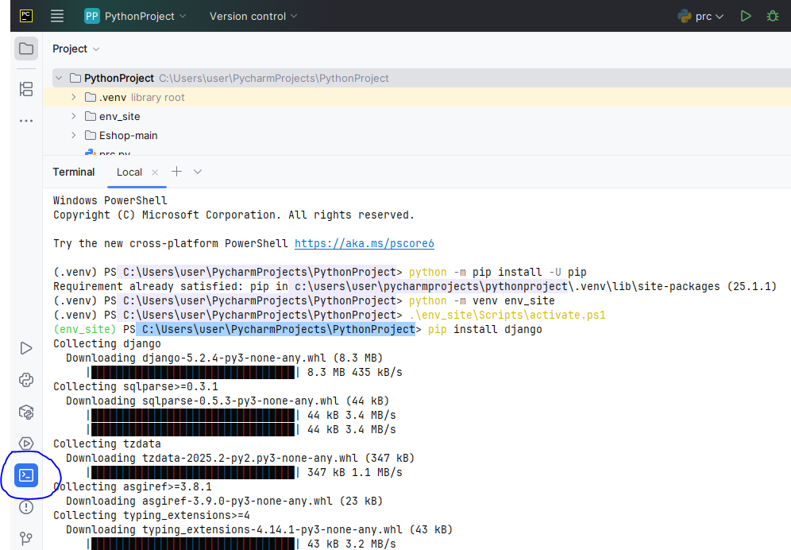
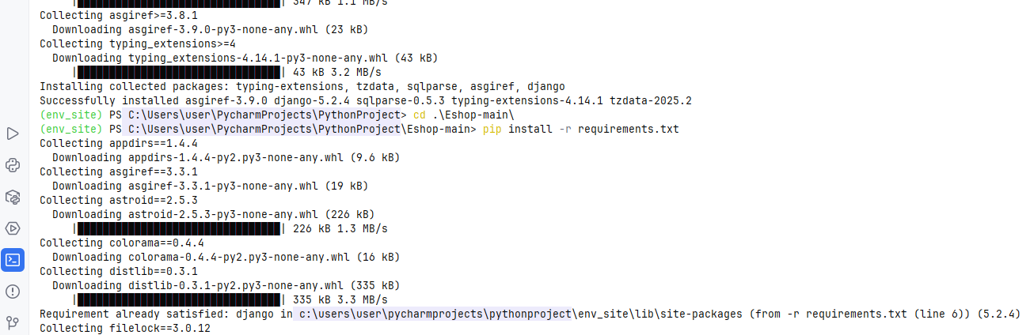
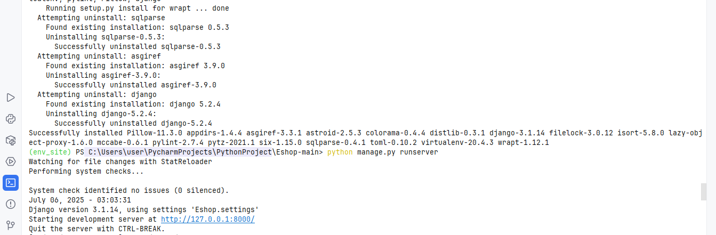
Step :5 will get URL and click that
http://127.0.0.1:8000/

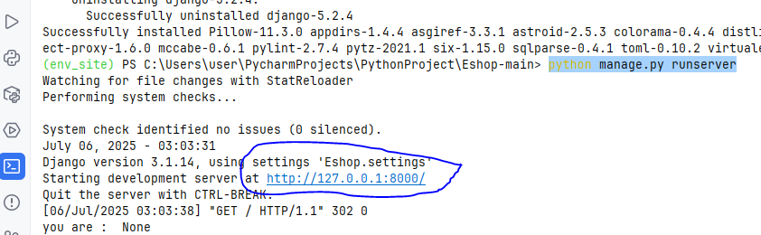

Step :6 will get Website

